4353 Assignment 2

Group 2: Jordan Foster, Chi Ngo, Christopher Randall

Answer these questions:

1. Provide link to GitHub repository for TAs to view the code? (1 point)

https://github.com/ctngo2512/4353_Assignment2.git

1. Discuss if your design and development methodology has changed since assignment 1 and why? (1 point)

- Our original development methodology was Rapid Application Development because we didn’t have much planned at the beginning and wanted to keep updating our application as we go.

- Our current development methodology is more like the Waterfall Model because we started with setting up the Login/Register Page first and only went onto the next step, the profile page, then later the Fuel Quote Form, when we are finished with the previous step.

1. List what front end technologies you are using and why. List who is responsible of doing what in your group? (2 points)

- We are using Javascript, HTML, CSS and Javascript’s React for our front end.

- Chi will do the login/register page and profile page with profile form.

- Jordan is in charge of all the visuals and special effects for the pages and setting up Firebase database to work with our program.

- Chris will do the Fuel Quote form.

1. Provide screen shots of your front end, each page? (5 points)

Log-in page:

Sign-up page:

Profile:

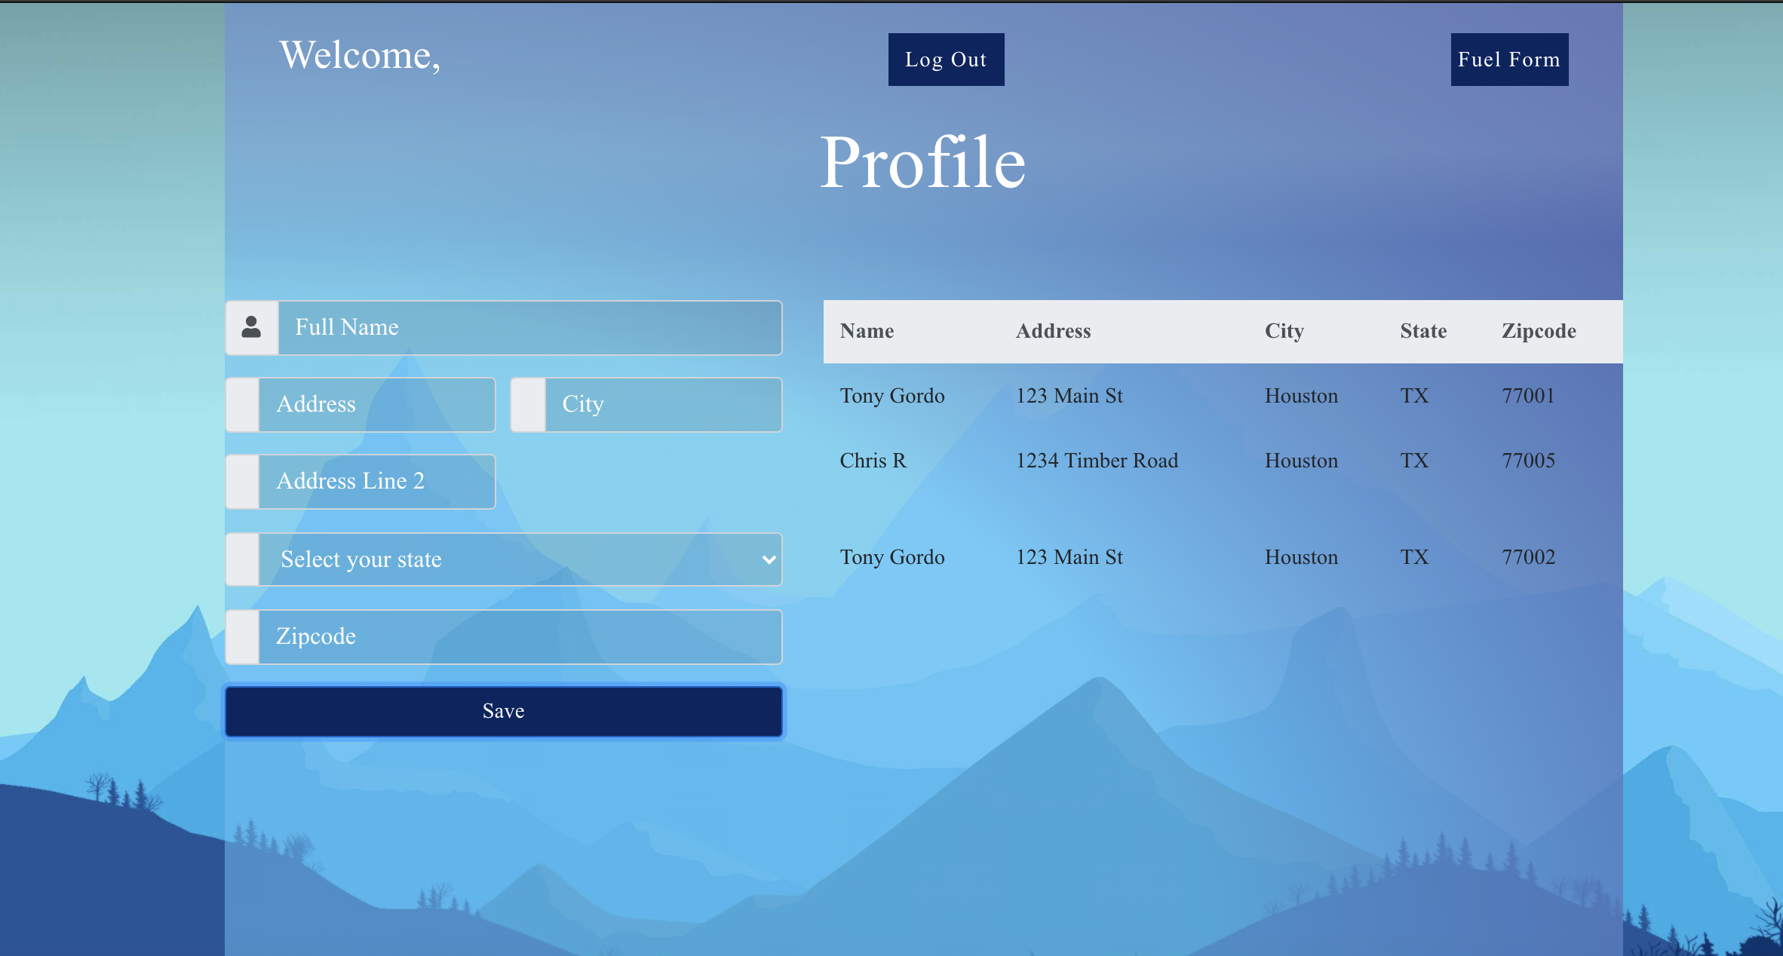

Fuel Page: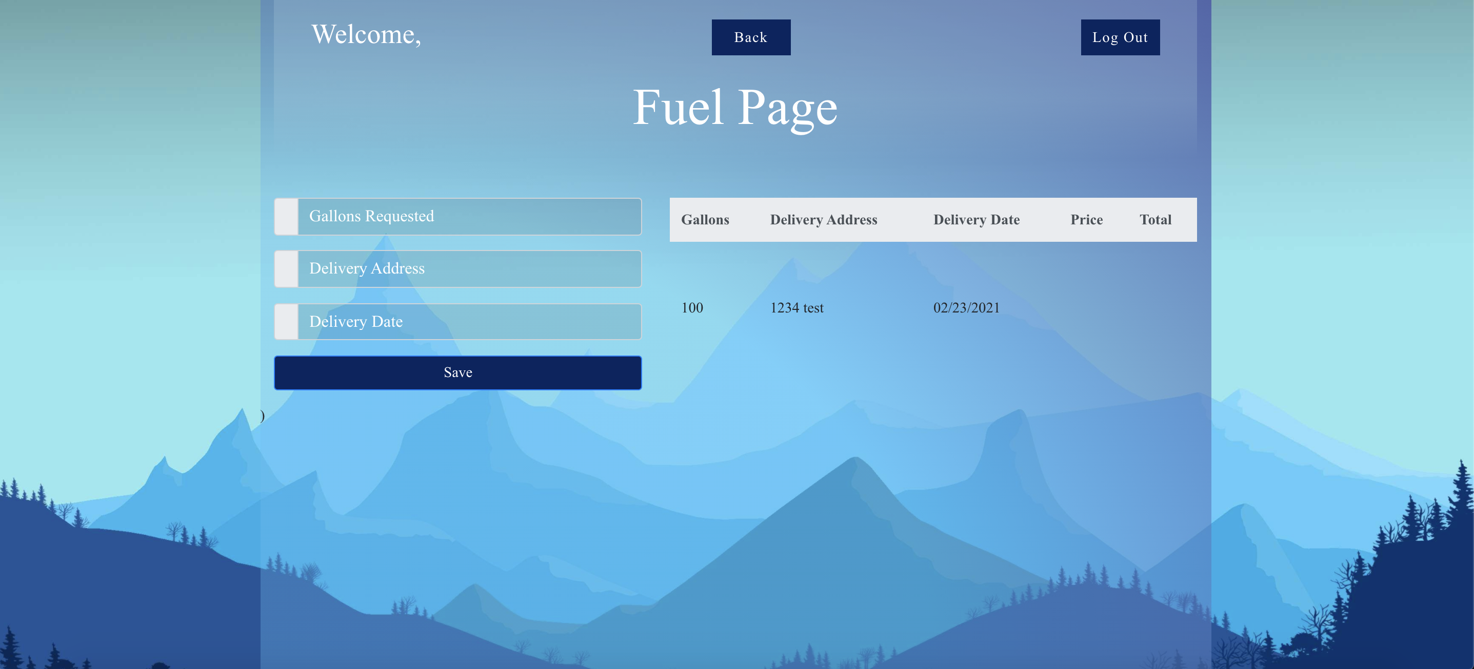

1. IMPORTANT: list who did what within the group. TAs should be able to validate in GitHub, otherwise team members who didn't contribute will receive a ZERO.

- Chi: made login/register page, profile page, connected Firebase Authentication to login/register, added fuel page to existing profile page

- Jordan: made login page logo, added background and special effects for login/register page and profile page, added Firebase Realtime Database to profile page, connected fuel page to the rest of the pages

- Chris: made the fuel form for the fuel page and set up fuel page